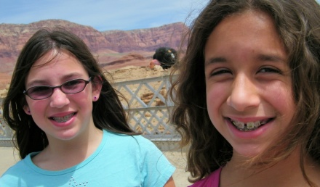
Tessa & Heidi
Lee's Crossing, Arizona

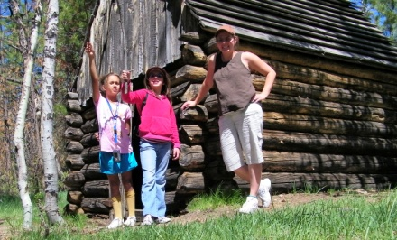
Tessa, Heidi & Theresa
North Rim Grand Canyon, Arizona

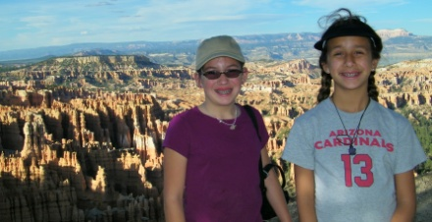
Tessa & Heidi
Bryce Canyon, Utah

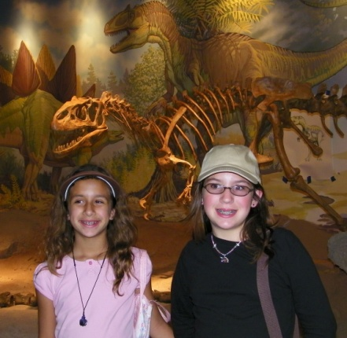
Heidi & Tessa
Dinosaur National Park, Utah

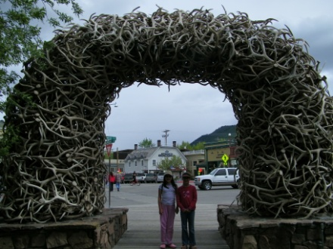
Tessa & Heidi
Jackson, Wyoming

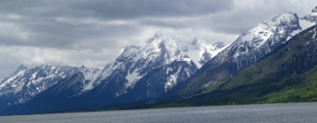
Grand Tetons, Wyoming

Hello Mrs. Peterson's Class and Families,

My name is Ms. Davidson and I am a student teacher from Northern Arizona University. I have the great pleasure of being placed in your child's classroom.

As a student at NAU I earned a grade point average of 4.0 and I am on the Dean's List. I am a member of the Golden Key International Honor Society, and in November I happily passed my Arizona Educational Proficiency Assessments the first time around.

I have spent the last 1-1/2 years as the library clerk at Gavilan Peak School. Before becoming a library clerk for DVUSD, I was a paraprofessional. It was as a paraprofessional that I realized how much I enjoyed working with children, and decided to go back to school in the evenings to become a teacher.

I am the mother of two beautiful girls, Heidi (age 10) and Tessa (age 13). Last summer we went on a two week trip where we visited the North Rim of the Grand Canyon, Bryce Canyon, Dinosaur National Park, the Grand Tetons and Yellowstone. We ended up driving 3,000 miles through five different states. It was an awesome adventure.

I look forward to spending the next sixteen weeks getting to know you and your children.

Sincerely,
Theresa Davidson

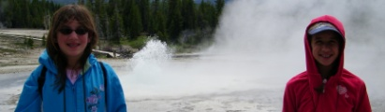
Tessa & Heidi
Yellowstone, Wyoming

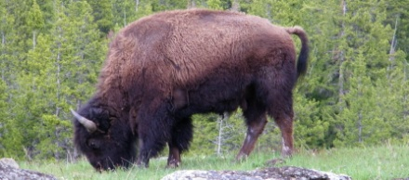
Buffalo, Yellowstone

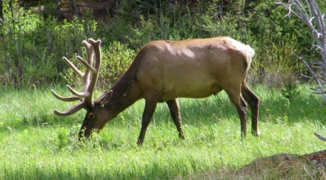
Elk, Yellowstone

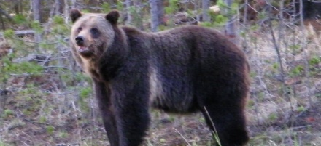
Bear, Yellowstone

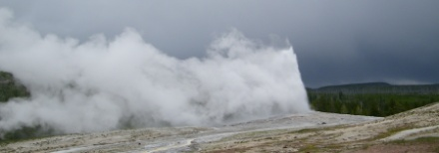
Old Faithful, Yellowstone

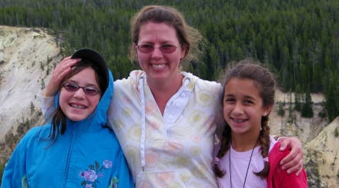
Tessa, Theresa & Heidi
Yellowstone

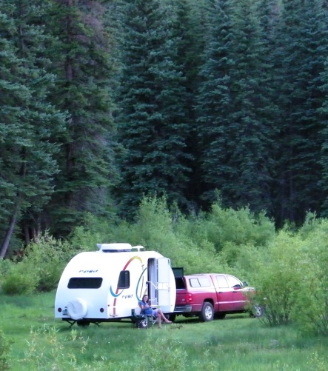 Our Hotel on Wheels
Colorado

